# **M03 Discussion - Final Project Check-In**

**Group 2: Dim Huai, Karima Kouadri Boudjelthia, Micheal Mekoya**

Our team has decided to create a project management software application called "Sweet Delight Bakery System." The purpose of our system is to enhance the efficiency of Sweet Delights, a local bakery, by streamlining operations and improving customer engagement. Our primary goal is to create an integrated system that manages orders, tracks inventory, facilitates customer interactions, ensures user authentication, and generates sales reports.

The scope of our project includes developing a user-friendly online platform where customers can easily place orders, view their order history, and receive updates on promotions and new products. The system will also allow the bakery to manage its inventory, ensuring they have the necessary ingredients in stock. We aim to implement secure user authentication to protect customer information and provide a seamless experience.

In terms of the general design, our system will consist of three main classes: User, Product, and Order. The User class will handle customer accounts and authentication, the Product class will manage the bakery's product catalog and inventory, and the Order class will handle order creation, tracking, and fulfillment.

I have attached a UML Class Diagram outlining the initial design of our system. We are excited to embark on this project and believe it will be a valuable tool for the project leader and our team.

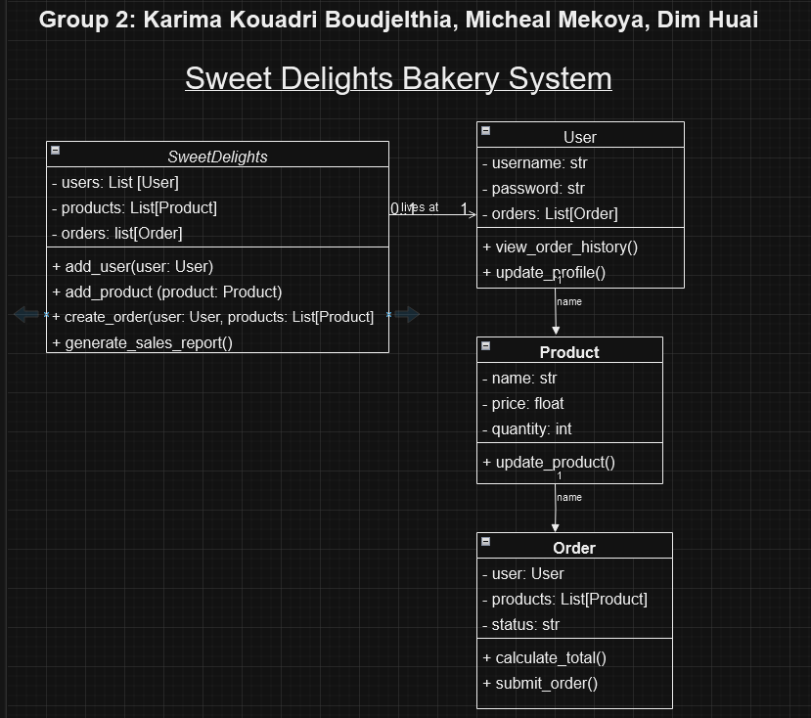

Please provide your thoughts and suggestions to help us refine our project proposal.